**Below is the difference on the features that are included per the plan:**

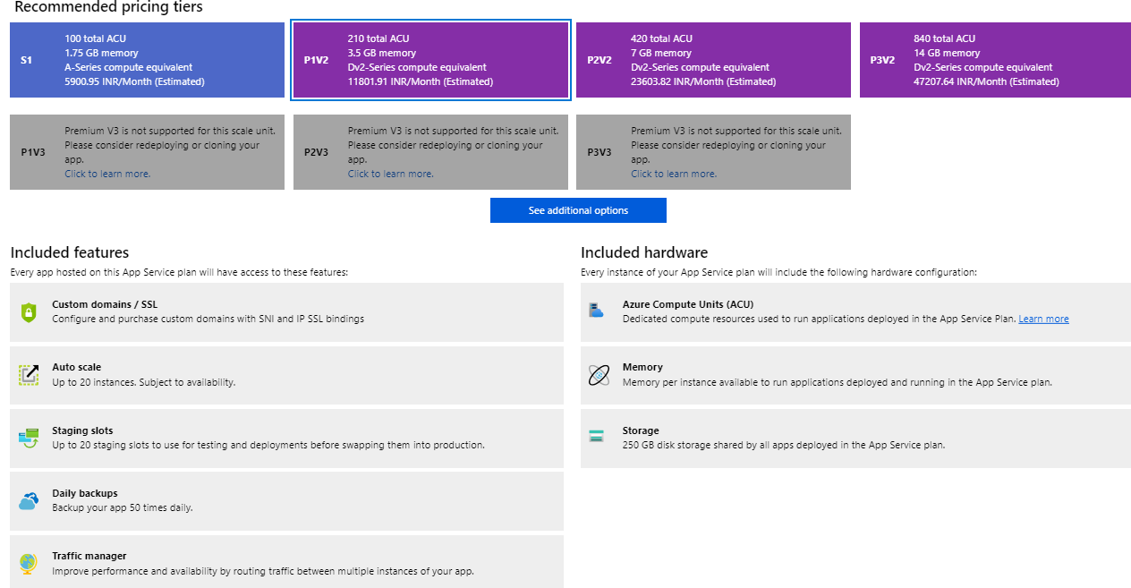

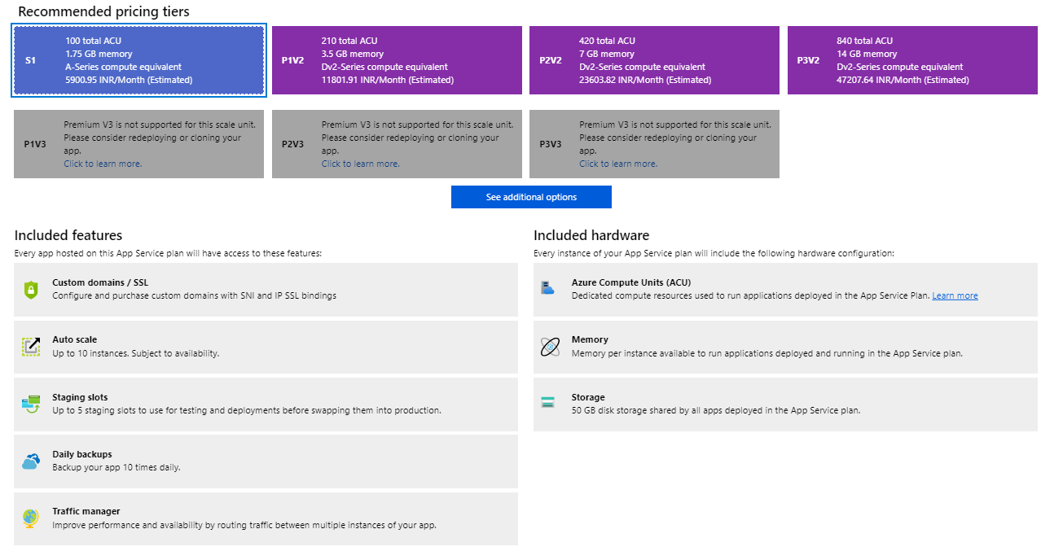

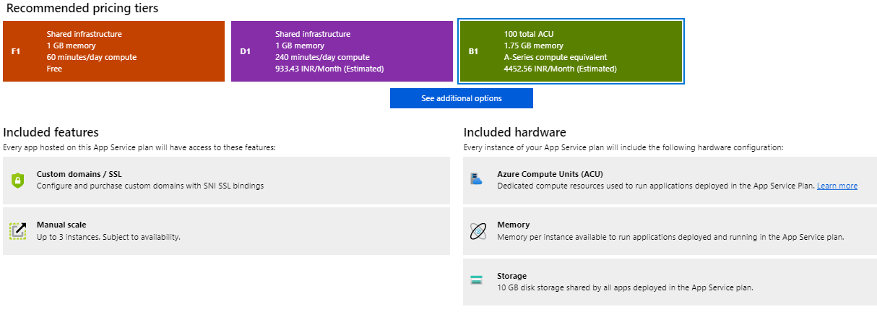

**Below are the Cost Difference:**

|  |  |  |  |  |  |  |
| --- | --- | --- | --- | --- | --- | --- |
| Resource | Name | SKU | Cost Per Month | Cost Per Year | Difference Per Year | Difference Per Month |
| App Service | ASP-PlatformxUIgroup-824f | B1 | 4452.56 INR | 53430.72 INR | 75,316.56 | 6,276.38 |
| P1V2 | 10728.94 INR | 128747.28 INR |

|  |  |  |  |  |
| --- | --- | --- | --- | --- |
| S1 | 5364.47 INR | 64373.64 INR | 64373.64 INR | 5364.47 INR |
| P1V2 | 10728.94 INR | 128747.28 INR |